**HALF TERM ACTIVITIES @**

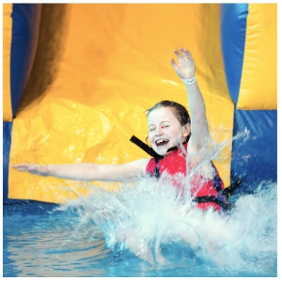**ST IVES LEISURE CENTRE**

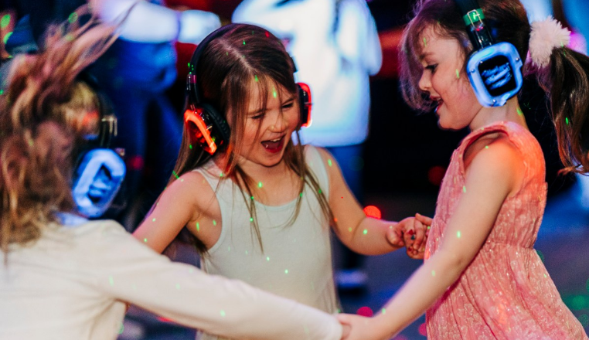

**MONDAY**

INTENSIVE SWIMMING LESSONS @ 0830 AND 0915 POOL INFLATABLE @ 1315

**TUESDAY**

INTENSIVE SWIMMING LESSONS @ 0830 AND 0915

**WEDNESDAY**

INTENSIVE SWIMMING LESSONS @ 0830 AND 0915 SILENT DISCO @ 1630-1730 AND 1730-1830

**FRIDAY**

POOL INFLATABLE @ 1315

**SATURDAY**

SWIM 1300-1400 SILENT DISCO 1400-1500 COMBO

**WE HAVE FAMILY FUN SWIMMING IN BOTH POOLS FROM 0900 DAILY.**

Please visit our website: https://www.better.org.uk/leisure-centre/cornwall/st-ives or app for full timetables and booking options.